Week 6 Lab Activity

David Abeiku Saah
Computer Science Department
CS323: Database Management / Database Systems
Mr Stephane Nwolley
September 29, 2023
Assigned database: Store Inventory Management System.
List of tables (from sketches)
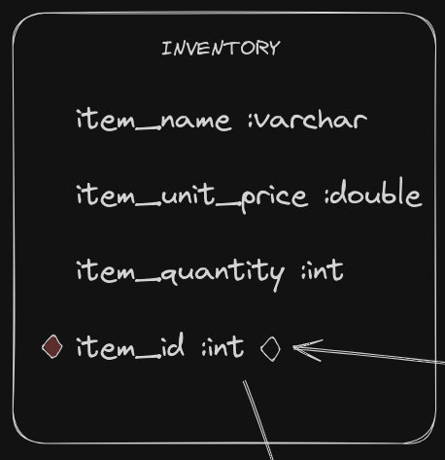
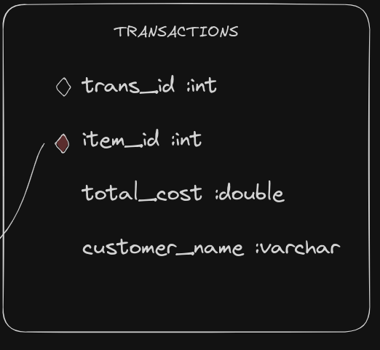
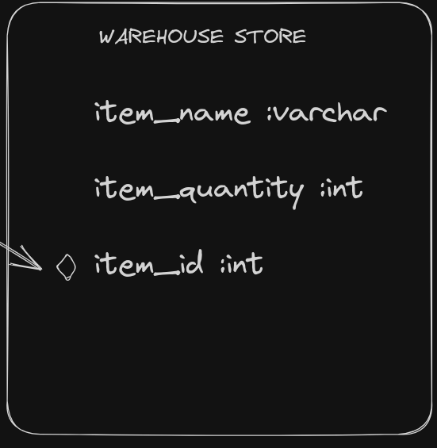
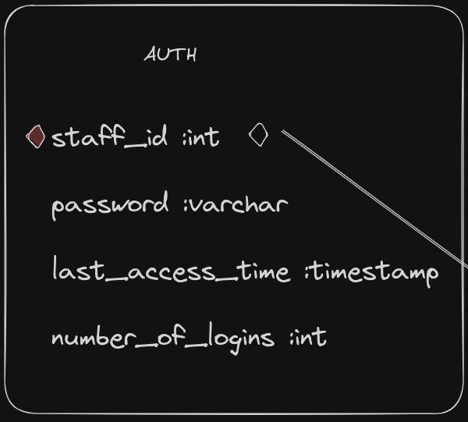
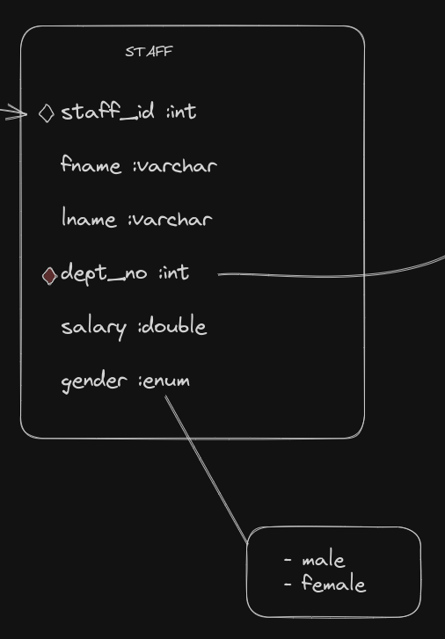
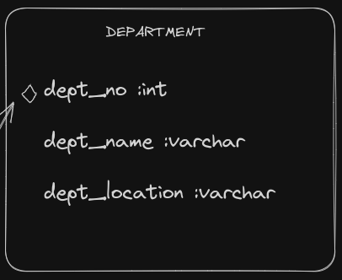
Conceptual Design (Generated by workbench)
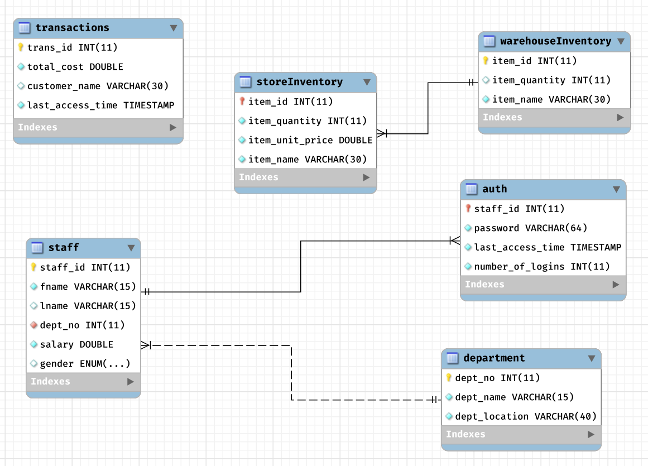
Updates
- There was the need to keep track of a list of items bought by a customer. However, mysql does not support array types and also custom data types to leverage that functionality.
  - An idea for a fix was to use a table to hold the item ids of the sold products and use trans_id to access them. To simulate the functionality of a list of items, I allowed duplicated trans_id. That way, a SELECT command with WHERE = trans_id will get the list of item_ids that is connected to the transaction.
- Added trans_time to transactions table to keep track of the time a transaction is made.

Conceptual Design (after updates)
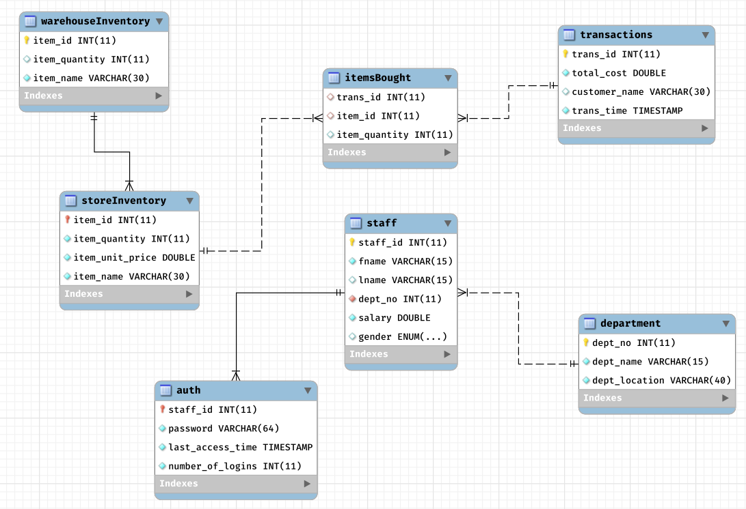
Keys in the Database
Attribute | Key type → Relation
staff_id | - Primary key → auth  - Primary key → staff  - Foreign key → auth
dept_no | - Primary key → department  - Foreign key → staff
trans_id | - Primary key → transactions  - Foreign key → itemsBought
item_id | - Primary key → warehouseInventory  - Primary key → storeInventory  - Foreign key → storeInventory  - Foreign key → itemsBought
item_name | - Candidate key → warehouseInventory  - Candidate key → storeInventory

Functionalities for Store Inventory Database
Prompt for chatgpt: “list 10 functionalities for a storeinventory database system that has the following relations: auth, department, itemsBought, staff, storeInventory, warehouseInventory, and transactions.”

Response (screenshots):
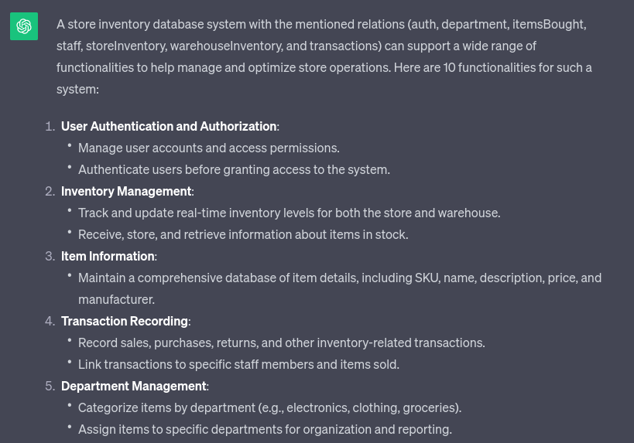

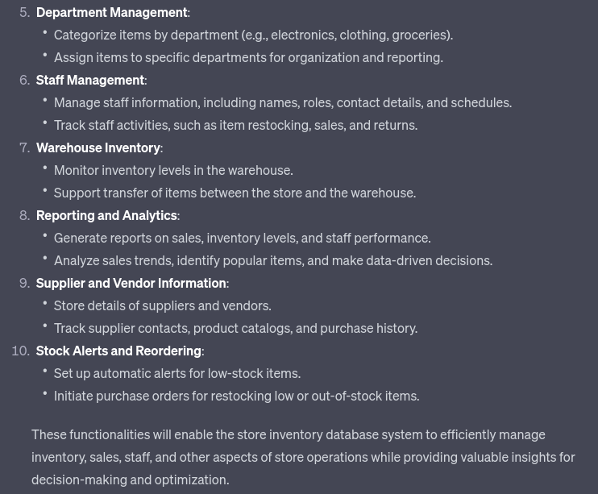
Chosen functionalities:
- Staff management.
- Transaction recording.
- Stock alerts and reordering.
- Reporting and analytics.
- Inventory management.
- Item information.
- Warehouse inventory.

